Miss. M Munnhar

[Company name]  [Company address]

soen6222-User interface document

The Register/Login page is a key entry point to the website for all types of users, including volunteers and general users. This part of the system is where new users sign up for an account and existing users log in to access additional features. For volunteers, creating an account through this page allows them to access, track, and participate in various tree-planting events and volunteer activities hosted by the organization. General users who wish to contribute to the cause, track their impact, or access the website’s resources can also sign up or log in here.

The Register/Login page satisfies the project’s **requirement number 1: User registration and login**. This requirement ensures that users have a secure and streamlined way to create a personal profile, which the system then uses to customize their experience and manage individual data. The login system also establishes a basis for secure data access, enabling the website to safely handle user data and ensure only authorized users access specific resources, like event participation and impact tracking. In summary, this page facilitates user engagement by making registration easy and central to accessing all other site functionalities.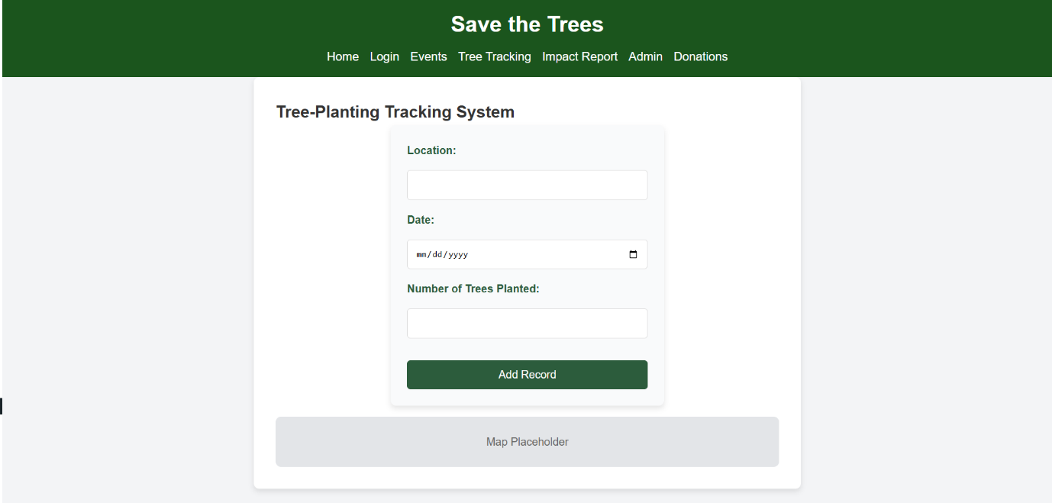

The Tree Tracking page is a dynamic area of the website that allows logged-in users—both general users and volunteers—to view the progress of planted trees. This page provides an interactive and informative view, where users can see a mapped display or list of trees that have been planted as part of the organization’s environmental initiatives. Volunteers, who contribute directly by planting or caring for trees, can use this page to monitor the growth and maintenance status of specific trees they have worked with. General users, on the other hand, can view the collective impact of the organization’s efforts and track how their donations or participation contribute to broader environmental goals.

This page fulfills **requirement number 2: A tree-planting tracking system**, providing a visual representation of the organization’s progress and allowing users to observe the real-world impact of their contributions. The tracking system not only builds transparency but also strengthens user engagement by keeping participants informed and connected to the outcomes of the project. In addition, this page reinforces the organization’s commitment to transparency and environmental impact, inspiring continued support and involvement from the community.

The Volunteer Event page is a central feature of the website where users and volunteers can explore all upcoming events organized by the organization. This page is designed to engage users by providing them with the details of various tree-planting and environmental initiatives, such as the date, location, and specific tasks for each event. Volunteers can easily register for events through the page, helping them keep track of opportunities to contribute to the cause. In addition to registration, the page includes a feedback system, allowing volunteers to share their experiences and provide input on the events they have participated in.

This page addresses **requirement number 3: Volunteer event registration** by offering a clear and user-friendly interface for users to sign up for events. By allowing volunteers to register directly on the page, the system helps the organization manage event participation and logistics effectively. It also meets **requirement number 10: User feedback system** by providing an interactive platform for volunteers to submit their feedback after attending events. This feedback system is essential for the organization to improve future events, gather insights, and enhance volunteer satisfaction. Overall, this page not only facilitates event participation but also fosters an environment of continuous improvement and user engagement.

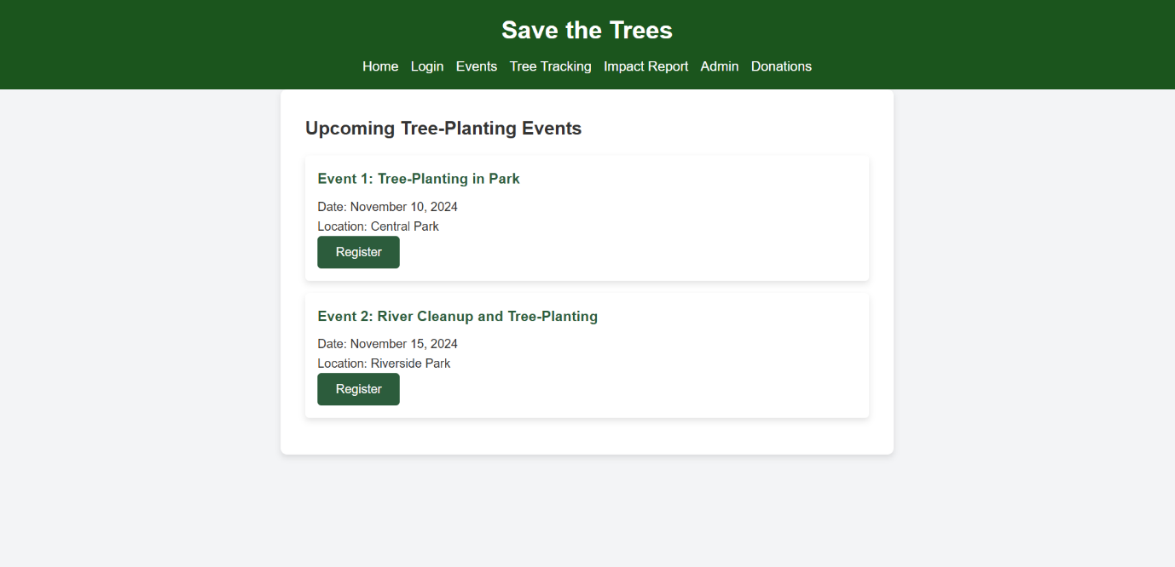

he Donation page plays a vital role in enabling users and volunteers to support the environmental initiatives through financial contributions. On this page, users can easily make donations to the cause, whether they are funding tree-planting efforts, supporting event logistics, or contributing to other environmental projects managed by the organization. The page is designed to offer multiple payment options, ensuring convenience for users who wish to donate securely. Detailed information about how the donations are used, including the direct impact of their contributions, is also provided, giving users transparency and reassurance about where their money is going.

This page fulfills **requirement number 4: Donation processing**, ensuring that users can contribute to the cause effortlessly. By integrating secure and efficient donation processing, the page helps to streamline the donation process, enabling users to make financial contributions quickly and confidently. The donation system also supports the overall sustainability of the organization by generating necessary funds for the continued success of tree-planting events and other environmental initiatives. In summary, the Donation page not only provides a simple way for users to support the mission but also reinforces the organization’s commitment to transparency and responsible use of funds.

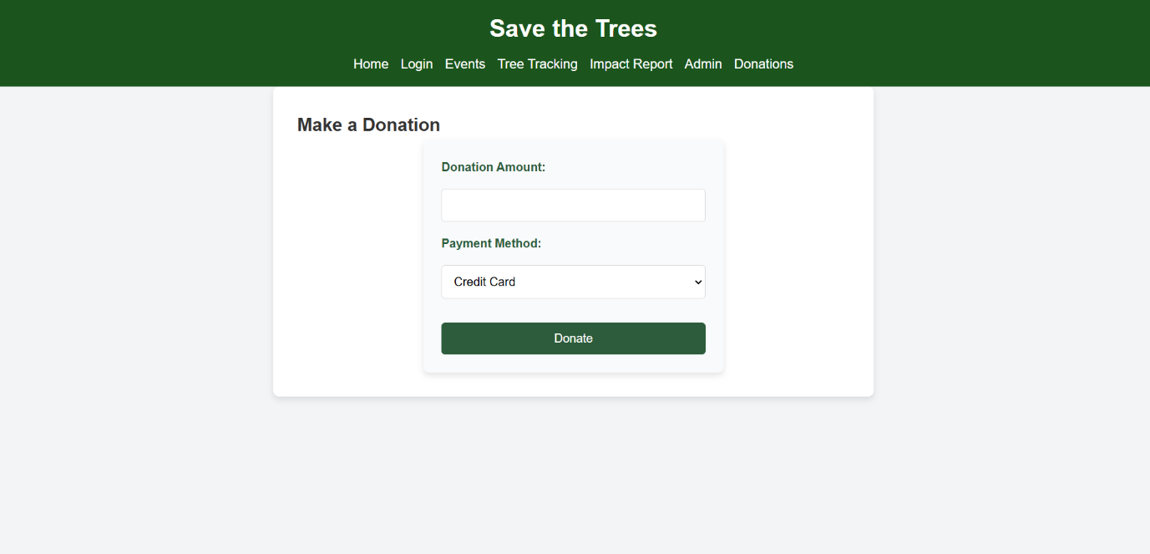

The Impact Report page is an essential feature that provides users and volunteers with detailed metrics about the organization's activities, offering a transparent view of the impact their efforts and donations are making. This page displays key data, such as the total number of trees planted, areas covered, volunteer hours logged, and financial contributions raised. Users can see how their involvement is directly contributing to the organization’s environmental goals, helping to foster trust and encourage continued support. Volunteers can also track the progress of specific initiatives and view the outcomes of the events they participated in, further strengthening their connection to the cause.

This page satisfies **requirement number 6: Impact Reporting**, by offering a clear and comprehensive overview of the organization's progress and the results achieved through volunteer and donor contributions. The Impact Report system is crucial in promoting transparency, ensuring that users feel informed and confident about where their time, efforts, and money are being allocated. It also helps demonstrate the effectiveness and success of the organization's initiatives, motivating users to stay engaged and contribute to future projects. Overall, this page plays a pivotal role in reinforcing the accountability of the organization and celebrating the collective impact of the community.

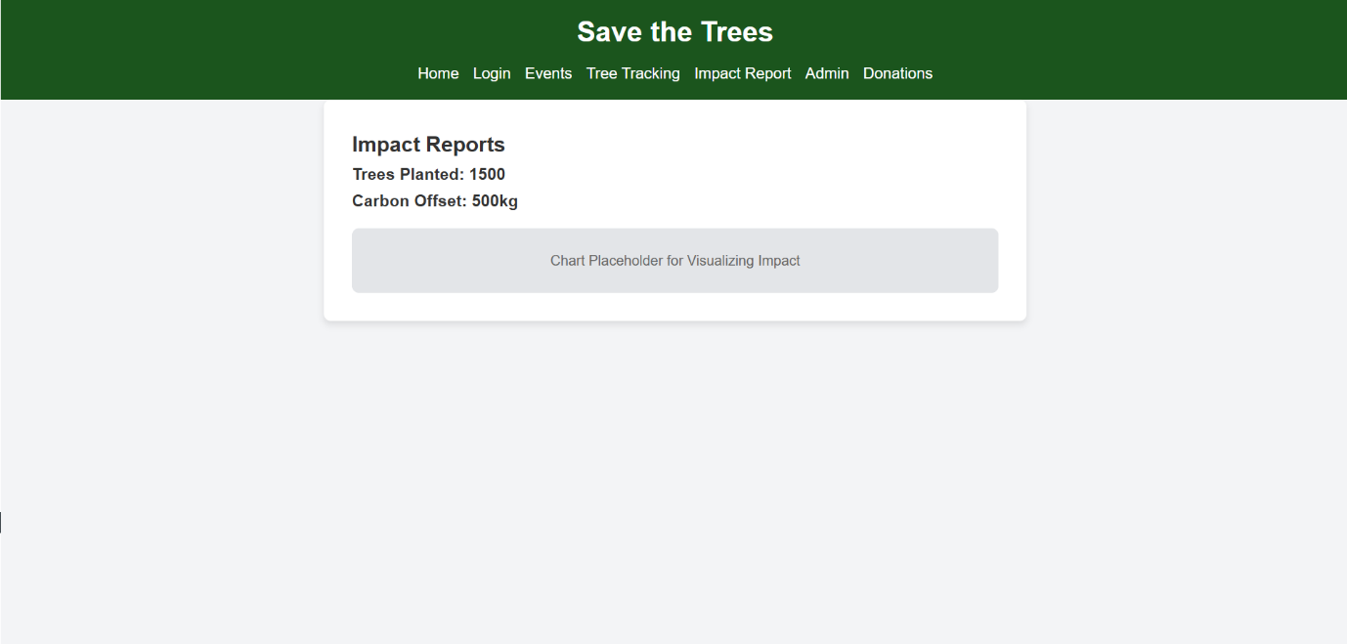

The Admin Dashboard is a specialized section of the website that is accessible only to administrators. It provides them with comprehensive control over the management of key aspects of the organization’s operations. Through this page, administrators can efficiently manage users, organize and oversee events, process donations, and generate detailed reports about the organization's activities and impact. The interface is designed for easy navigation, with clearly defined sections that allow admins to access specific tasks, such as adding or removing users, creating new events, and monitoring financial contributions. Additionally, the report generation feature enables admins to assess the organization's progress, analyze data, and make informed decisions to improve the system and its outreach.

This page satisfies **requirement number 9: Admin Dashboard**, as it provides a centralized platform for administrators to oversee and manage the core functionalities of the website. The dashboard plays a critical role in ensuring the smooth operation of the organization by allowing admins to track users’ participation, monitor event success, manage donations, and generate valuable insights through reports. With this tool, administrators are empowered to make strategic decisions and maintain the operational efficiency of the website, ensuring its continued success.

These admin management pages serve as the core tools for administrators to handle and oversee the various elements of the web application. They are an extension of the **Admin Dashboard** and provide specific sections for managing users, events, donations, and generating reports, which are critical to the functionality and smooth operation of the system.

1. **Manage Users Page**: Here, administrators can view, add, edit, or delete user accounts. This page allows the admin to manage both volunteers and general users, ensuring that all users have the correct access and permissions. By managing user accounts effectively, the admin can ensure that only authorized individuals participate in events or contribute to the cause.
2. **Manage Events Page**: This section allows the admin to organize and oversee all upcoming events. They can add new tree-planting events, edit details, or cancel events that are no longer needed. The page helps the admin ensure that all events are properly scheduled and communicated to volunteers, keeping everything well-organized and efficient.
3. **Manage Donations Page**: The donations management page is where administrators can track the incoming financial contributions. Admins can view the donation history, issue receipts, and ensure that all contributions are processed correctly. This page helps maintain transparency and accountability in managing the funds received for the cause.
4. **View Reports Page**: This section allows the admin to generate detailed reports about various activities within the system. Admins can access data about events, donations, user participation, and overall impact. The reports can be used to analyze performance, identify trends, and make strategic decisions about future initiatives.

These pages satisfy **requirement number 9: Admin Dashboard**, providing administrators with all the tools necessary to manage the website’s users, events, donations, and performance in an organized and efficient way. They empower administrators to ensure smooth operations and make data-driven decisions that help the organization continue its environmental work effectively.

